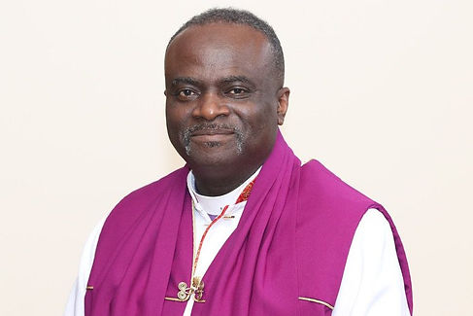
Apostle Ronnie Lee Parson Sr., DMIN.
Apostle Ronnie Parson was born in Wadesboro, NC, the seventh of nine siblings. In 1981 while working as an engineer at Bell Laboratories in Murray Hill, New Jersey. During the stay in New Jersey, he was baptized in Jesus name and received the Holy Spirit while attending the Islen Community Church, Islen New Jersey. While serving under Pastor Arthur Jenkins at the Community Church, he was divinely called into the ministry. A crisis experience that continues to have him seeking to, as the Apostle Paul says, “Apprehend why he was apprehended.”
Apostle Parson has served in the pastoral ministry for over thirty-one years and is presently the senior pastor of The Living Church Ministries located in Charlotte and Statesville North Carolina (NC) and Diocesan Bishop of the Piedmont Diocese (NC).
Pastor Parson served as the executive secretary under Bishop Ralph White of the Metrolina Diocese for over twenty years. He served in the executive office of Church Of Our Lord Jesus Christ (COOLJC), and has been there for over ten years. He developed software to fully automate the entering, printing, and stamping of new credentials.
Parson holds an earned Doctorate in Marriage and Family Counseling, and a Masters of Theology & Arts in Christian Counseling, both from Gordon-Conwell Theological Seminary. Also, he holds a Bachelor of Biblical Studies (Lee University) and Associates in Electrical Engineering Technology. He recently served as professor of Pastoral Counseling and Pastoral Theology at William L Bonner College (WLBC), Columbia, SC. He has also taught courses in Homiletics, Church & Pentecostal History, and Biblical Studies. Presently he teaches Pastoral Theology and Christian Counseling for the online segment of WLBC College. At the 95th Convocation, he was appointed to serve as head of the Counseling Department for the Church Of Our Lord Jesus Christ of The Apostolic Faith Inc, overseeing a staff of licensed professional counselors.
Parson is a published author of several pamphlets and three books: “I Took a Beating for this Blessings,” “A Cellular Communication Approach to Brief Marriage Counseling,” and “The Divine LGBT Agenda, being a believable believer in a post-truth world.” Also, he co-authored engineering publications: 1983 at Bell Laboratories, Murray Hill, New Jersey.
Apostle Ronnie Parson and His wife and best friend, Lady Rubina Parson, travel extensively teaching, training, and conducting seminars that range from leadership essentials, marriage, and family development to a variety of contemporary topics and theological themes impacting the twenty-first-century His ultimate goal is to please his Lord and Savior Jesus Christ and hear him say, “Well done good and faithful servant.”
Apostle Parson was consecrated as an apostle in COOLJC and appointed to Region XII in July 2018. Apostle Parson overseas the following regions:

